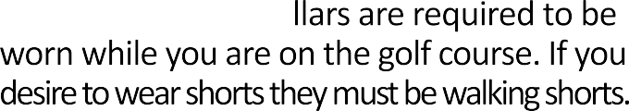

**Annual Golf Tournament**

**Wednesday, Oct 11, 2023**

John Pellegrino 561-252-8655

Vicki Byrne 561-373-6510

Fax 561-688-8807

Email: [klingeljohn@gmail.com](mailto:klingeljohn@gmail.com)

Wednesday, Oct 11, 2023

Attn. John Klingel

John Pellegrino **561-252-8655**

Vicki Byrne **561-373-6510**

**Tournament Sponsorship:** See separate form

**601 Heritage Drive; Suite 448**

**Jupiter, FL 33458**

# Annual Golf Tournament October 11, 2023

**Winston Trails, 6101 Winston Trails Blvd. Lake Worth, FL 33463**

# Premium Sponsorship Form

## Company Name:

Contact Person: MailingAddress: City State Zip Phone: ( ) Fax: ( )



**Circle the item you would like to sponsor if it is available.**

**If your company is interested in providing items including golfballs, hats, towels, prizes, etc.,**

**Please contact:**

|  |  |
| --- | --- |
| **Food Sponsor:** | **$500** |
| **Beverage Cart #1:** | **$500** |
| **Beverage Cart #2:** | **$500** |
| **Happy Hour:** | **$500** |
| **Closest to the Pin:** | **$500** |
| **Signs** | **$300** |
| **Event sponsors:** | **$250** |

**John Pellegrino 561-252-8655 OR Vicki Byrne 561-373-6510 Total $**

Please mail this form and your check or fax form with credit card information to: PBCSMCA, 601 Heritage Drive,

Suite 448, Jupiter FL 33458

Ph 561-373-6510 • Fax 561-688-8807

pbcroofers.com • [klingeljohn@gmail.com](mailto:klingeljohn@gmail.com)